STRATEGIC PLAN
2024 - 2027

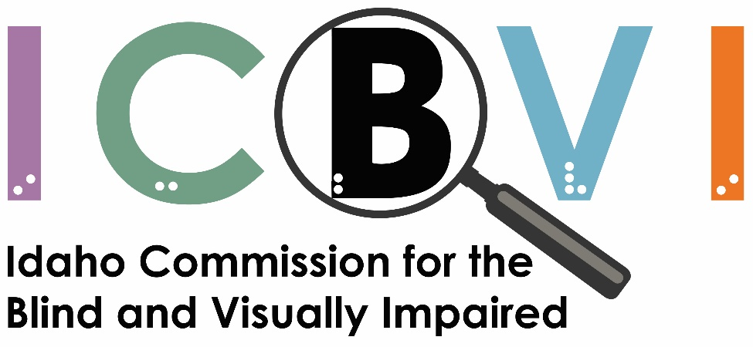

MISSION STATEMENT
Our mission is to empower persons who are blind or visually impaired by providing vocational rehabilitation, skills training, and educational opportunities to achieve self-fulfillment through quality employment and independent living.

VISION STATEMENT
To provide Idahoans who are blind or visually impaired the same opportunities as their sighted peers to pursue full and productive lives.
OPERATING PHILOSOPHY
We believe in the abilities of people who are blind or visually impaired and in each other as professional colleagues. We believe in respecting individual differences, facilitating individualized services both to our client partners and to each other. We believe people who are blind or visually impaired, like others in society, benefit most when contributing to their communities rather than completely depending upon them. We believe our services must be marked by effective communication, professionalism, mutual support, managed change, teamwork, and intra/interagency cooperation.

EXECUTIVE SUMMARY
This plan addresses four programs administered by ICBVI: 1) Vocational Rehabilitation, 2) Business Enterprise Program, 3) Independent Living, and 4) Sight Restoration.
The Vocational Rehabilitation (VR) program is operated in compliance with the Federal Rehabilitation Act of 1973, as amended by the Workforce Innovation and Opportunity Act (WIOA) enacted on July 22, 2014. WIOA introduced several significant changes to the VR program, including 6 new primary indicators of performance.

Goals and objectives for the VR program in this plan are supported under Idaho priorities in the 2020-2023 Workforce Innovation and Opportunity Act (WIOA) Combined State Plan. Furthermore, the six Common Performance Measures under section 2.2.1 of this plan are performance targets the state VR program has negotiated with our federal oversight, the Rehabilitation Services Administration (RSA). Since these are new performance measures for the VR program, RSA has taken a “phased in” approach to implementation.

The Business Enterprise Program (BEP) is a federally sponsored, state-administered program that helps Idahoans who are blind or visually impaired to set up a business managing cafeteria or food vending facilities. Goals and objectives for this program are established by the ICBVI management team.

The Independent Living Program is another federal program sponsored by RSA and administered by ICBVI. This program serves blind and visually impaired individuals who are in need of adaptive independent living skills. Qualified rehabilitation teachers work with individuals in their homes and communities to help them live as independently and safely as possible. Goals and objectives for this program are established by the ICBVI management team.

The Sight Restoration Program is a state sponsored program that assists eligible individuals to pay for medical expenses related to procedures which preserve or restore vision. The purpose of these services is to allow individuals to retain their independence at home or to maintain employment. Goals and objectives for this program are established by the ICBVI management team.

VOCATIONAL REHABILITATION PROGRAM

Goal 1: Increase independence and employment outcomes through quality vocational rehabilitation services.
Objective 1: Provide quality training and career services to individuals in the vocational rehabilitation program.

Performance Measure 1.1.1: Number of participants enrolled in training / education leading to a recognized industry credential or employment.
Benchmark: ≥ 40% over the life of this plan.

Objective 2: Improve the employment outcomes of students through the provision of Pre-Employment Transition Services (Pre-ETS).

Performance Measure 1.2.1: Percentage of secondary students who become enrolled in post-secondary training that leads to a degree or industry recognized credential or employment.
Benchmark: ≥ 60% over the life of this plan.

Goal 2: Improve the quality of vocational rehabilitation services through program evaluation and quality assurance activities.
Objective 1: Meet or exceed the targets for the Common Performance Indicators established by the Rehabilitation Services Administration (RSA)¹.
Performance Measure 2.1.1: Meet or exceed the negotiated targets for the following 6 performance measures:
Performance Measure | SFY 2024 | SFY 2025 | SFY 2026 | SFY 2027
Employment Rate – 2nd Qtr. After Exit | 60% | TBD | TBD | TBD
Employment Rate – 4th Qtr. After Exit | 58.3% | TBD | TBD | TBD
Median Earnings – 2nd Qtr. After Exit | $4500 ($9.38 per hour) | TBD | TBD | TBD
Credential Attainment² | 44.0% | TBD | TBD | TBD
Measurable Skill Gains³ | 57.6% | TBD | TBD | TBD
Effectiveness in Serving Employers | N/A | TBD | TBD | TBD
¹ To Be Determined
² Percentage of participants in a postsecondary education or training program and received a credential/certificate during the program or within one year after exit.
³ Percentage of participants, who are in an education or training program that leads to a recognized postsecondary credential or employment and who are achieving measurable skill gains toward such a credential or employment.
Note: The measures for SFY 2025-2026 will be negotiated with RSA in Spring of 2024.

Objective 2: Evaluate the participant satisfaction survey to assess the participants level of satisfaction with vocational rehabilitation services¹.

Performance Measure 2.2.1: Participant satisfaction rate.
Benchmark: ≥ 90% over the life of this plan.

BUSINESS ENTERPRISE PROGRAM

Goal 1: To provide a wide range of services, support, and entrepreneurial opportunities for licensed program vendors through the operation of food and vending service businesses.
Objective 1: Assist vendors in achieving their vocational potential and increase annual average vendor earnings.

Performance Measure 1.1.1: Average vendor earnings.
Benchmark: Maintain or increase over the life of the plan.

INDEPENDENT LIVING PROGRAM

Goal 1: To teach blind and visually impaired citizens of Idaho to adjust, function, and live as independently as possible in their home and community settings.
Objective 1: Provide quality training services in home and community settings.

Performance Measure 1.1.1: Number of Idahoans served in these programs.
Benchmark: 100% served.

SIGHT RESTORATION PROGRAM

Goal 1: To provide support for medical services that allow individuals to retain their independence in the home or to maintain employment.
Objective 1: Provide quality supportive services that helps to prevent the onset of blindness and/or makes a significant improvement in functional vision.

Performance Measure 1.1.1: Number of Idahoans served.
Benchmark: 100% served.

